Come to Jacob's Creek, in the mountains of western Pennsylvania. A religious camp for all ages, it combines a family vacation with the wonderful doctrines of the New Church.  Plenty of companionship, but also time for quiet spiritual contemplation;  A feeling of true connection with New Church ideas and life.  Spiritual growth and learning, and good fellowship with friends.  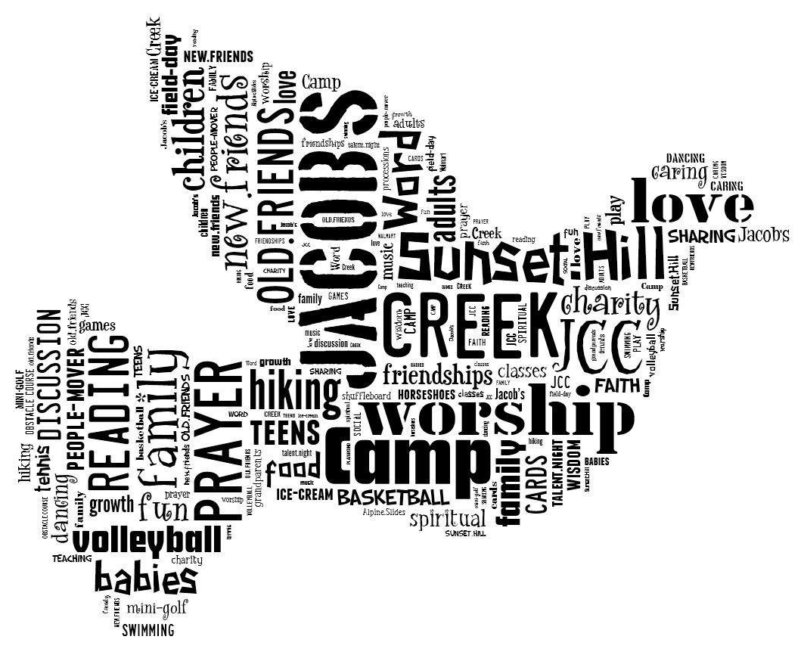  Ages of attendees range from tiny babies to those in their 80s! Accommodations suit any age, paths are paved, and there are ramps for wheelchairs and strollers.
  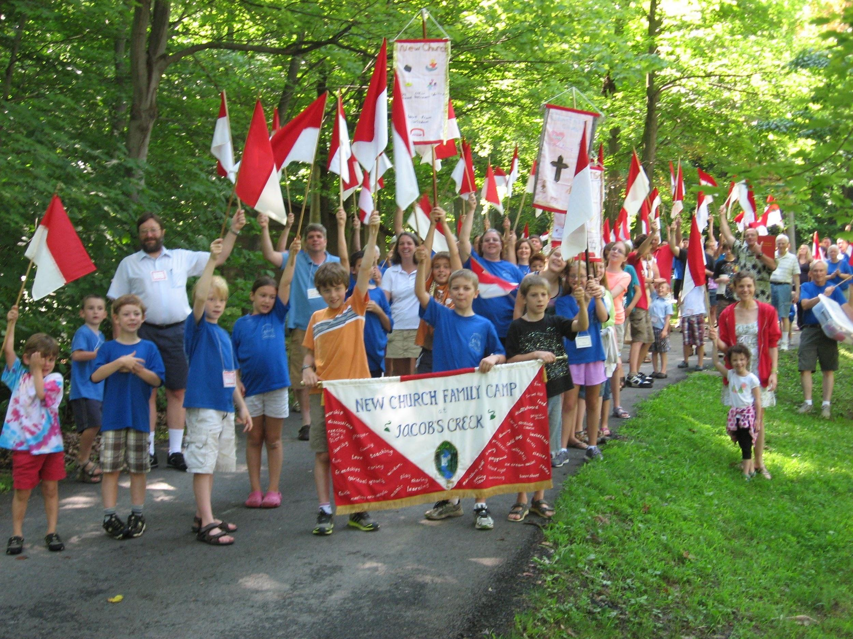
  Jacob’s Creek Family Retreat is a great place to come as a New Church family. As one attendee said a few years ago:
  “The countdown for camp has started for us! Our family loves this camp because it brings us closer to the Lord, we catch up with friends, and it is super-relaxing! No cooking involved or parents running kids from point A to B. If this is your idea of a good vacation, join us!”
  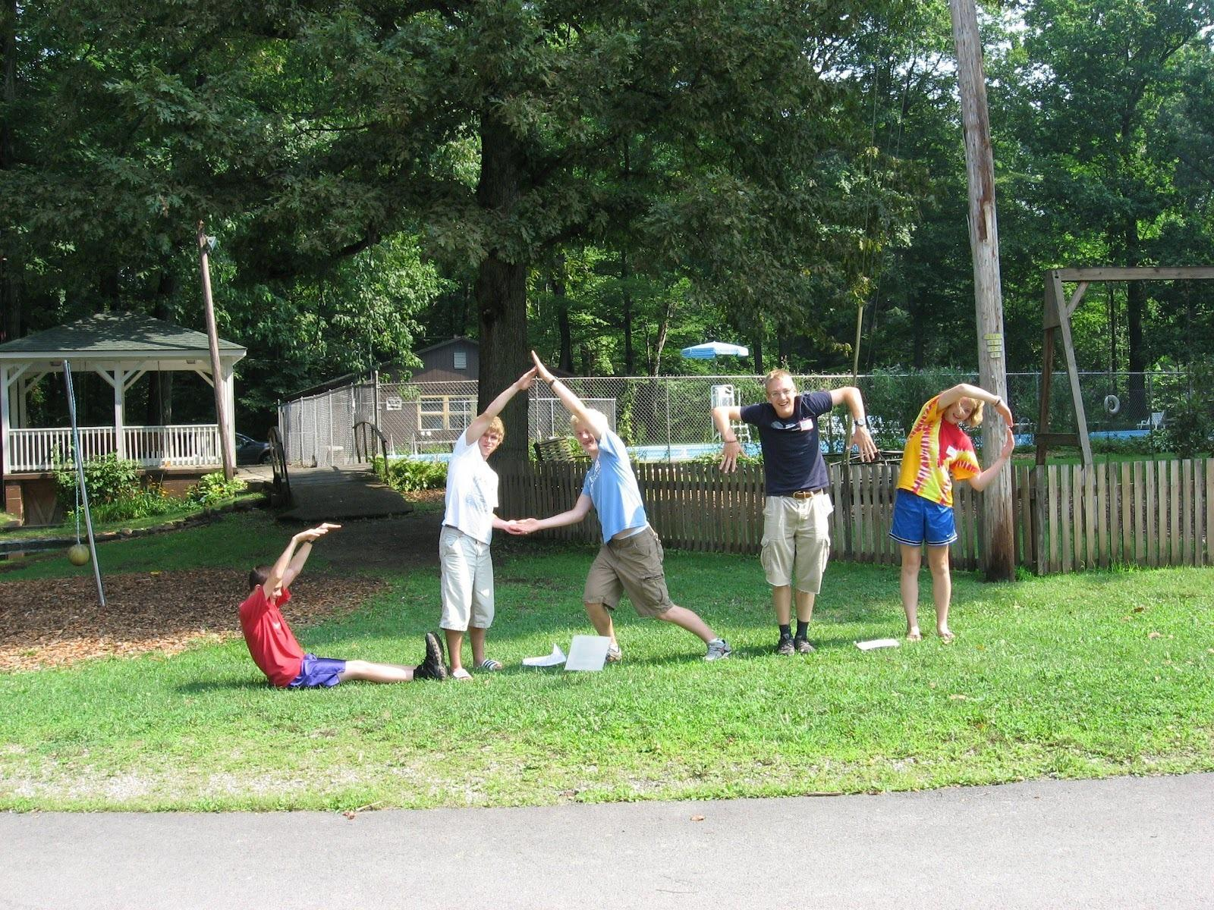
  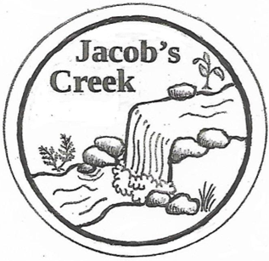
  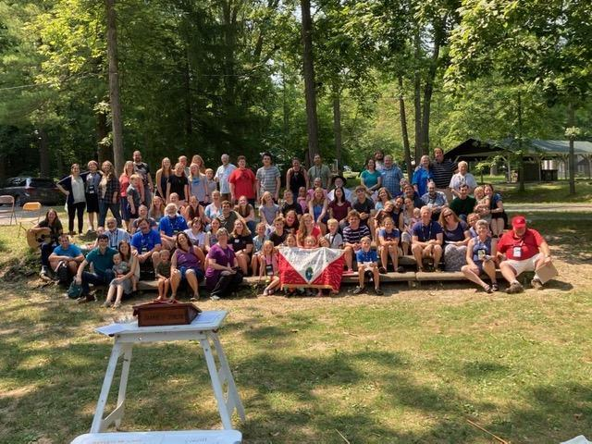
  Jacob’s Creek Family Retreat
  July 23-26, 2026

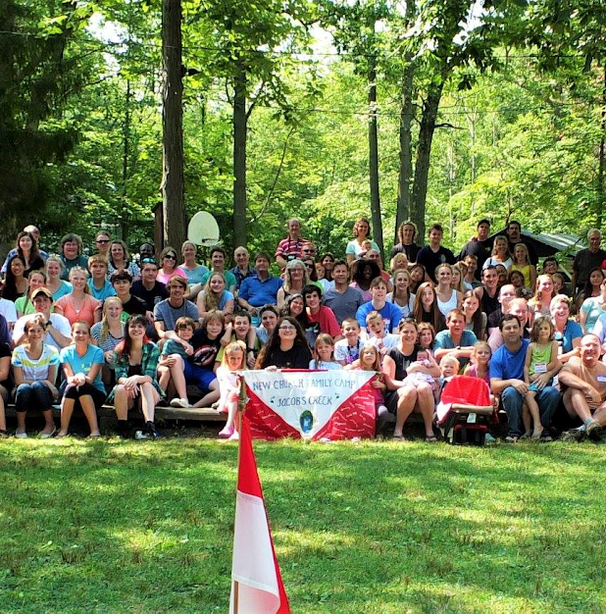  This Year’s Theme:  Use: The Soul and Life of All Heavenly Joy  he  “All who shun evils as sins perform uses from the Lord, while all who do not shun evils as sins perform uses from the devil…. One is like gold within which is dross, the other is like gold with pure gold within.”  ~Divine Providence 215  We are created to be useful to others and serve the Lord, in this life and the next.  How do we allow the Lord to prepare us for our own special and unique use in His heavenly kingdom? |  |  | About Jacob’s Creek:  Jacob’s Creek Family Retreat takes place at the Laurelville Retreat Center in the beautiful Laurel Highlands, found in western Pennsylvania. Under the auspices of the General Church of the New Jerusalem, this retreat has as its mission to serve attendees with good spiritual food, warm friendships, and a community of faith in the light of the threefold Word.  “This camp is a little slice of heaven.”  Why Jacob’s Creek?  People of all ages love Jacob’s Creek because of the loving spiritual sphere, comfortable accommodations, great food, interesting activities, and time to spend with family and dear friends. |  |  | 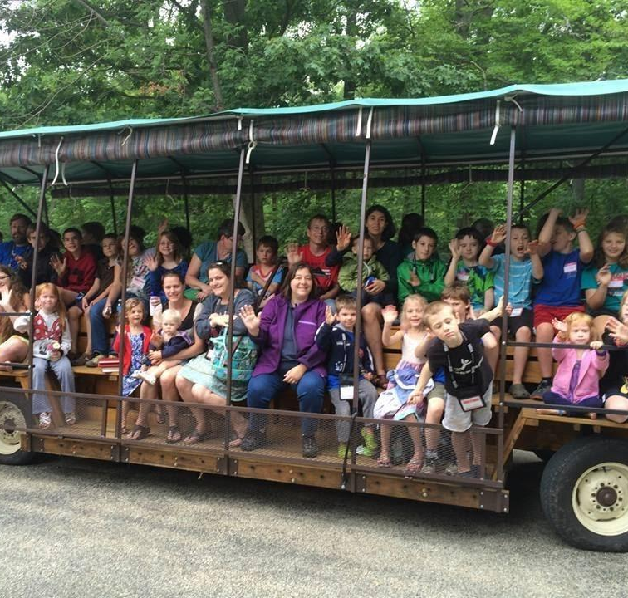  How to Register:  Check out our website!  jacobscreekfamilyretreat.org  Here you can find details such as how to register, directions, what to bring, costs to attend, the children’s program, accommodations, daily schedule, and information on the lectures, discussions, and programs.  You can also contact us by email at jacobscreekfamilyretreat@gmail.com  Please friend us on Facebook, at facebook.com/JacobsCreekFamilyCamp  No computer? Call 412-782-2710 for a paper copy of the registration form.

